**Circuit and System-I Lab**

**Project Proposal**



**Spring 2022**

Submitted by:

Suleman Shah (**21PWCSE2059)**

Shahzad Bangash (**21PWCSE2059)**

Ali Asghar (**21PWCSE2059)**

“On my honor, as student of University of Engineering and Technology, I have neither given nor received unauthorized assistance on this academic work.”

Submitted to:

**Engr. Faiz Ullah**

3 July, 2022

Department of Computer Systems Engineering

**BLIND WALKING SMART STICK**

**INTRODUCTION:**

Almost 30 million people are blind according to the recent WHO Report. These blind people are totally dependent on others as they can’t walk alone. This is the reason why we have designed the Blind Walking Smart Stick device which will help blind people to walk with ease independently.

**COMPONENTS REQUIRED:**

1. Arduino UNO Board
2. HC-SR04 Ultrasonic Sensor
3. Buzzer
4. 9 Volt Battery

**CIRCUIT SKETCH:**

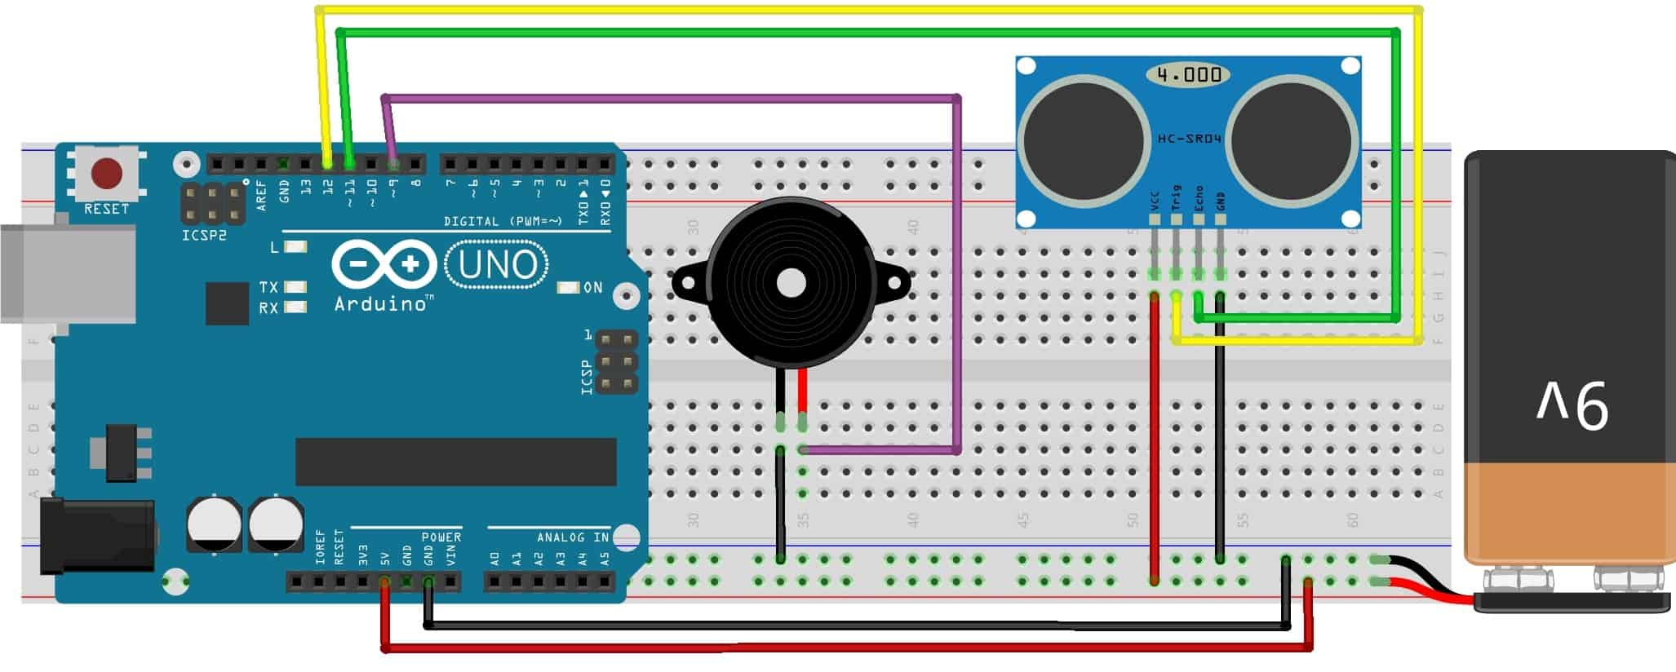

**CIRCUIT CONNECTIONS:**

1. Vcc pin of HC-SR04 is connected to 5 volt pin of Arduino
2. Trigger pin of HC-SR04 is connected to D12 pin of Arduino
3. Echo pin of HC-SR04 is connected to D11 pin of Arduino
4. The ground of HC-SR04 is connected to the GND pin of Arduino.
5. The positive terminal of the 9-volt battery is connected to the Vin pin of Arduino and the negative terminal is connected to the GND pin of Arduino.
6. A buzzer is connected between the D9 pin of Arduino and the GND pin.

**CIRCUIT & WORKING:**

The main objective of this project is to help blind people to walk with ease and to be warned whenever their walking path is obstructed with obstacles. As a warning signal via buzzer, whose frequency of beep changes according to the distance of the object. The closer the distance of obstruction, the more will be the buzzer beep frequency.

The main component used for this device is the Ultrasonic Sensor HC-SR04. The ultrasonic sensor transmits a high frequency sound pulse and then calculates the time to receive the signal of the sound echo to reflect back. HC-SR04 has a transmitter & receiver surface. One of them acts as the transmitter and transmits the ultrasonic waves. The other one acts as a receiver and receives the echoed sound signal. The sensor is calibrated according to the speed of the sound in air. The speed of sound is 341 meters per second in the air, and the distance between the sensor and object is equal to time multiplied by the speed of sound divided by two.

**Distance = (Time * Speed Of Sound) ÷ 2**

After the distance measurement, Arduino makes a beep format using a buzzer, when the distance is high, the frequency of beep is decreased and beep frequency is increased when the distance is low.